Team Agreement/Contract:

Name of people in group:

Matthew Tucker

Zakkary Hucksby

Johnathon Terry

Project objective:

1. Create an original game in 3D or 2D stile about surviving a Zombie apocalypse.
2. Create a gaming platform that is mobile and will be able to survive for up to or longer then 1 hour without charging.

Meeting days:

Every week: Tuesday at 1400.

Due dates:

The final project is due – 5/1/2020

Plane of action:

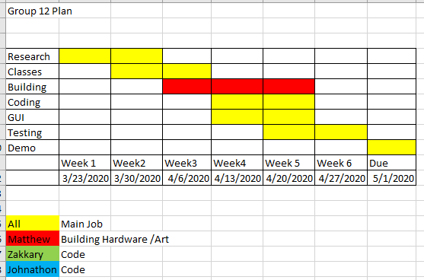

Who is doing what:

Matthew: I will create the gaming platform and provide any drawings needed for the game. Will assist with game engine help and coding help as needed.

Zakkary: I will code the player movements and interactions, code the Trader’s movements, and code the movements and attacks of the variety of zombies. Most of these tasks involve their classes.

Johnathon:

By signing this I agree to show up to every meeting and to provide my share of the work. If I do not, I give right to the others to kick me out of the group and or lose points on grade.

X____**Matthew Tucker**____

X____**Zakkary Huckaby**___

X___________________